
“I want you to PRINT this document and refer to it, make notes on it, and take advantage of it while you listen to our call.”
-Matthew Glanfield

Teleseminar Dial-In Details

Date: Thursday, July 5, 2007

Time: 10:00am (Pacific) / 1:00pm (Eastern)

Dial In: 1-218-486-3694

Pass code: 131242#

Webcast: http://www.bboteleseminarformula.com/members/webcast.php

Subject: Call 3 – Creating Your Sales Website

All training material can be found at http://www.bboteleseminarformula.com/members/

Special Note: This teleseminar starts on time according to www.Time.gov so please dial-in ten minutes early so you don’t miss any content. Your courtesy will be most appreciated.
Important Resources

Members Area:
http://www.bboteleseminarformula.com/members/

Members Forum:
http://www.bboteleseminarformula.com/members/forum

Overview:
http://www.bboteleseminarformula.com/members/overview.pdf

Live Webcast:
http://www.bboteleseminarformula.com/members/webcast.php

Member Support (and Matthew’s email address):
http://www.bboteleseminarformula.com/members/ask.php

Topic Ideas:
http://www.bboteleseminarformula.com/members/topics.pdf

Training Schedule

Module 1:
Overview, Choosing Your Topic, Getting Your Speakers

Module 2:
Creating Your Teleseminar Product

Module 3:
Creating Your Sales Website

Module 4:
Launching Your New Teleseminar Product

Overview of What We Will Accomplish

- You will choose a topic.
- You will plan the product you want to create.
- I will help you find experts to interview (or be the expert).
- You will create two teleseminar products (with the same expert).
- You will get your sales website created (I will provide templates and the service).
- You will have the affiliates’ page created (again, I will provide templates and the service).
- You will get your product ready to launch.
- I will promote your product (first-done, first-served).
- I will help you find JV partners to promote your product.

Sound easy enough? It is!

Your Website Sales Process

Sales Page

with opt-in box
PayDotCom

Register Page

Up-Sell Page

Download Page

Without Up-Sell

Register Page

Download Page

With Up-Sell
PayDotCom
Aweber Prospect List
Aweber Prospect List
Aweber Prospect List
No
Yes

Example – Sales Page
http://www.bboadwords.com



Notes

Example – Pop-Over Box

http://www.bbo12monthplan.com

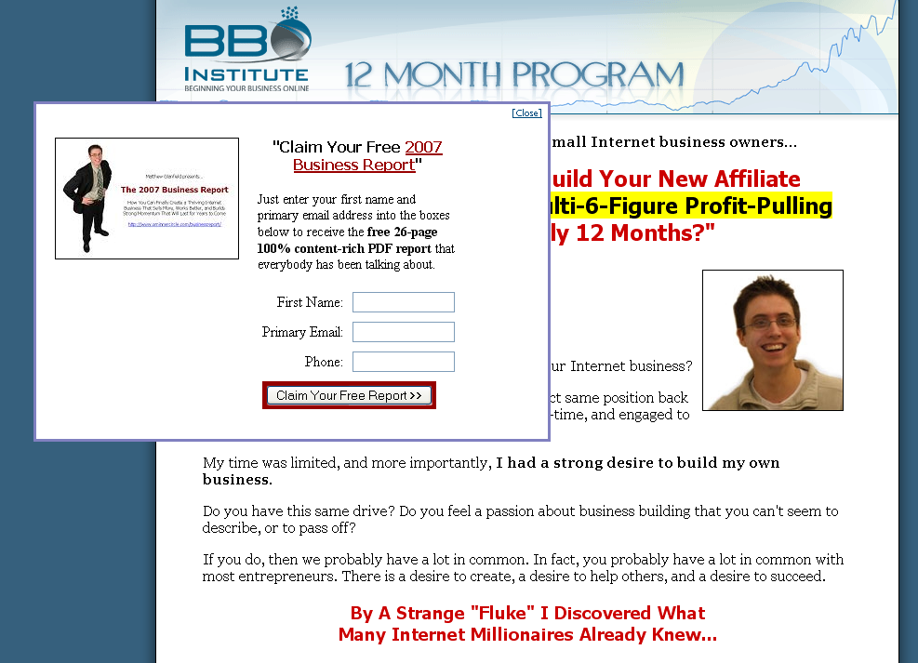

Notes

Example – Register Page

http://www.yoursqueezepage.com

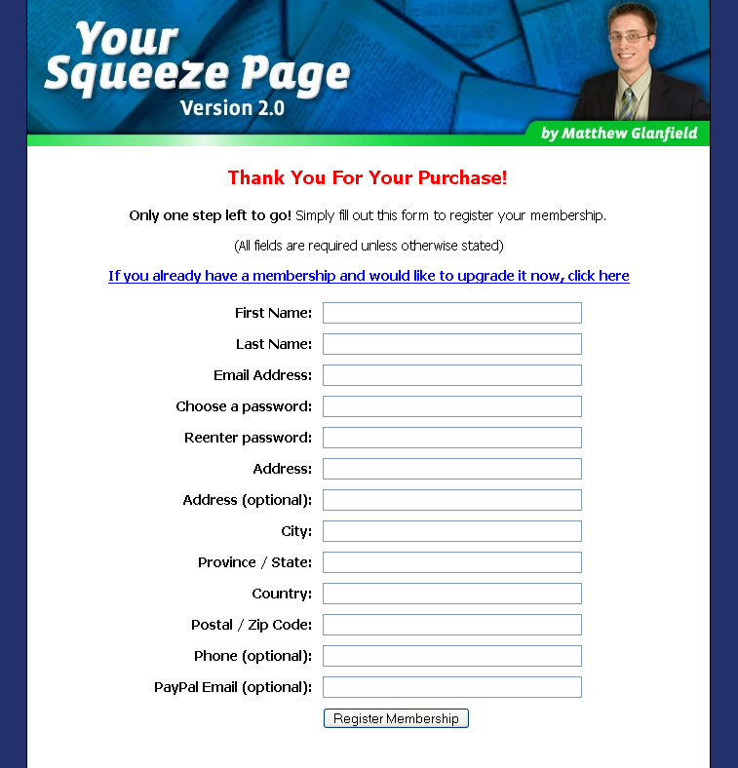
Only Name and Email are necessary for now

Notes

Example – Up-Sell Page

http://www.bboadwords.com/resale.php



Notes

Example – Up-Sell Page

http://www.bboadwords.com/resale.php

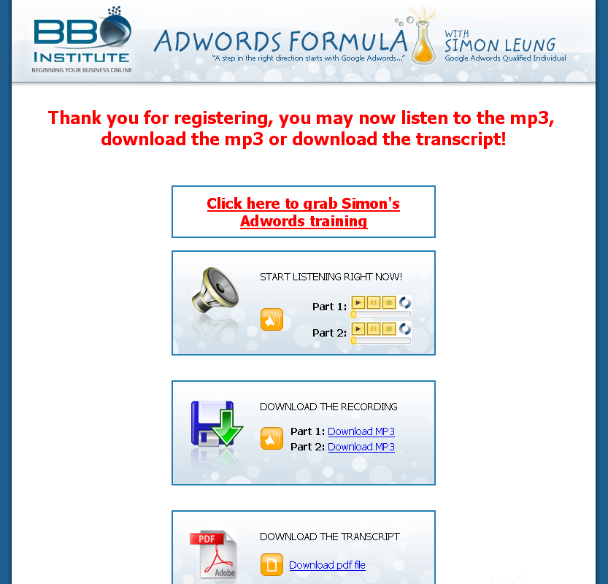

Notes

Example – Affiliate Page

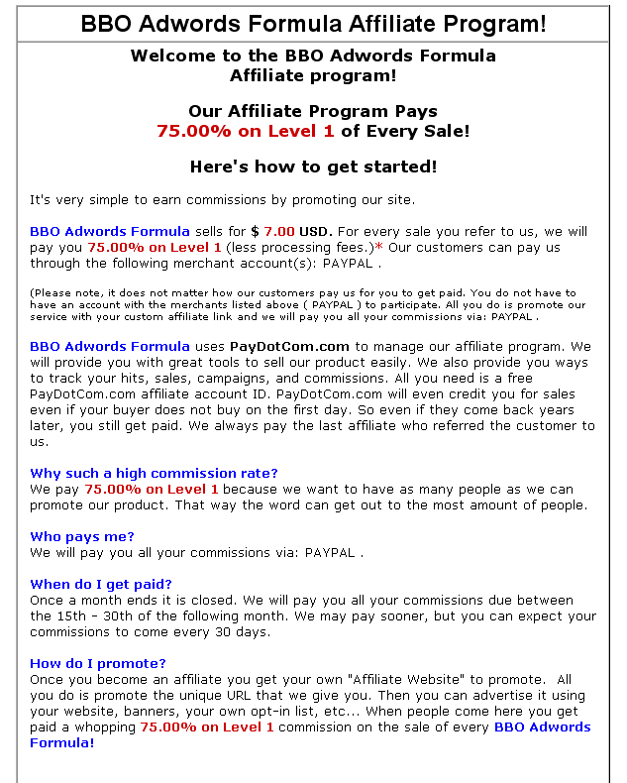

Tracking
What you should track:
- Opt-ins
- Sales
- Up-Sells
- Back-End Sales
- Shopping Cart Abandonments (advanced)

Notes

Resources to Use

Sales Tracking
http://www.funnelclick.com

Our Web Design Services
http://www.bbowebdesign.com

Payment Processor
http://www.bboinstitute.com/pdc.php

Web Hosting
http://www.aminnercircle.com/lunarpages.php

Other Resources
www.bboteleseminarformula.com/members/resources.php

Your Action Steps For Next Week

- Create your website

- Create your affiliate sign up page and one pre-written email.

- Send an email to Matthew when you are done.

